Salesforce AI-Powered Customer Support Ticketing System

1. Project Overview
The Salesforce AI-Powered Customer Support Ticketing System is designed to centralize and automate customer support operations. Organizations often face challenges in managing large volumes of support requests, ensuring timely responses, and maintaining consistent service quality. This project demonstrates how Salesforce can be used to streamline these processes through
automation, structured data management, and intelligent assistance.
The system utilizes Salesforce standard objects such as Account, Contact, and Case along with custom objects like Support Category, SLA Policy, and AI Feedback. Automation is implemented using record-triggered flows to automatically classify cases,
assign priority levels, and calculate SLA due dates. The system also provides suggested actions to support agents to improve their efficiency while handling customer issues.
By implementing this solution in a Salesforce Developer Org, the project showcases how businesses can reduce manual work, improve response time, and maintain better visibility over support operations. The project focuses on real-world scenarios
and demonstrates the practical application of Salesforce administration and automation tools.

2. Problem Statement
Customer support teams often struggle with managing a high volume of service requests while maintaining service quality and meeting SLA commitments. Manual handling of support tickets can lead to delays, misclassification of issues, inconsistent prioritization, and lack of proper tracking.
Many organizations lack a centralized system that can automatically categorize cases, assign priorities, and monitor SLA deadlines. As a result, support agents spend excessive time on administrative tasks instead of resolving customer issues.The objective of this project is to design a centralized and automated support ticketing system using Salesforce that improves
efficiency, ensures SLA compliance, and supports better decision-making through data-driven insights.

3. Requirement Gathering
Requirement gathering is an essential step in system design. In this project, the requirements were identified based on the
needs of customer support operations.
The system should allow support agents to create and manage cases easily. Each case should automatically be categorized based
on the issue type. The system must assign priority levels such as Low, Medium, or High depending on the severity of the issue.
SLA policies must be applied to ensure that cases are resolved within a defined time frame.
Additionally, the system should support monitoring through reports and dashboards. Managers must be able to track case status,
SLA breaches, and agent performance. Feedback mechanisms should also be included to evaluate AI-generated suggestions.
4. SYSTEM ARCHITECTURE

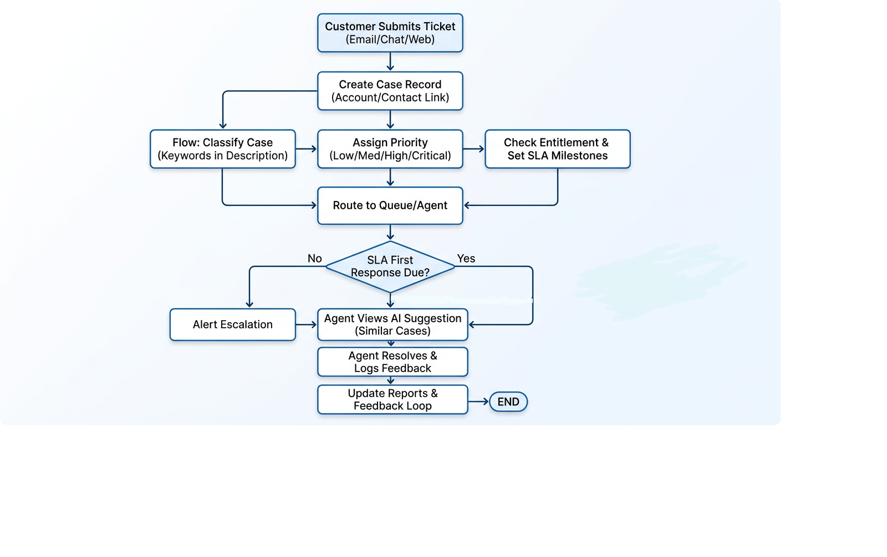
5. Functional Scope
The functional scope of the project defines the key features and capabilities delivered by the Salesforce-based Customer Support Ticketing System.The system is designed to manage customer support cases efficiently by automating case classification, priority assignment, SLA tracking, and agent assistance.
Users can create and manage customer support cases within Salesforce. Once a case is created, the system automatically classifies it based on the issue type and assigns an appropriate priority level. SLA policies are applied to calculate the expected resolution time for each case.Support agents can view suggested actions to help resolve cases more effectively. They can update case statuses, communicate with customers, and track progress until the issue is resolved.using reports and dashboards, while administrators manage system configuration, automation, and security settings.

6. Stakeholder Mapping
Stakeholder mapping identifies the key individuals and groups involved in the development, implementation, and usage of the Salesforce AI-Powered Customer Support Ticketing System.
The primary stakeholders include:
Customers – Customers raise support requests when they face issues with products or services. Their main expectation is quick and effective issue resolution.
Support Agents – Support agents are responsible for handling customer cases, resolving issues, updating case statuses, and interacting with customers.
Support Managers – Support managers oversee the support team’s performance. They monitor case resolution rates, SLA compliance, and overall support efficiency using reports and dashboards.
System Administrators – System administrators configure the Salesforce system, manage security settings, maintain automation flows, and ensure smooth system operation.
Business Stakeholders – Business stakeholders define requirements and ensure that the system aligns with the organization’s business goals and customer service strategy.
6.1. Execution Roadmap
The execution roadmap outlines the step-by-step implementation process followed to develop the Salesforce AI-Powered Customer Support Ticketing System. The project was executed in multiple phases to ensure smooth development, testing, and deployment.

Phase 1: Requirement Analysis and Planning
In this phase, the project requirements were analyzed and the overall system design was planned. Stakeholders were identified, project scope was defined, and the system architecture and data model were finalized.

Phase 2: Environment Setup
A Salesforce Developer Org was set up and configured. Lightning Experience was enabled and the basic environment was prepared for system development.

Phase 3: Data Model and Security Configuration
Standard objects such as Account, Contact, and Case were used to store customer and support information. Custom objects like Support Category, SLA Policy, and AI Feedback were created to extend system functionality. Profiles and permission sets were configured to implement role-based access control.

Phase 4: Automation and Case Classification
Record-triggered flows were created to automate case classification, priority assignment, and SLA due date calculation. This automation helps reduce manual work and ensures consistent case handling.

Phase 5: Agent Assistance and Feedback Loop
Suggested actions were configured to assist support agents in resolving cases efficiently. A feedback mechanism was implemented to capture agent responses about system suggestions.

Phase 6: Reporting and Monitoring
Reports and dashboards were created to monitor open cases, SLA breaches, and agent performance, providing valuable insights for support managers.

Phase 7: Testing and Validation
All system functionalities were tested using different scenarios to verify automation accuracy, data consistency, and system reliability.

Phase 8: Deployment and Documentation
After successful testing, the system configurations were finalized. Documentation was prepared and the system was made ready for demonstration and evaluation.

7. System Requirements
The system is implemented using Salesforce Developer Org with standard CRM capabilities and automation tools.
The main system requirements include Salesforce standard objects such as Account, Contact, and Case. Custom objects like Support Category, SLA Policy, and AI Feedback extend the system functionality.Automation is implemented using record-triggered flows. Reports and dashboards are used for monitoring system performance.
Security is managed through profiles and permission sets.
8. Agentforce Ai
Agentforce AI is used in the system to assist support agents in responding to customer cases more efficiently. It uses AI capabilities to analyze case information and generate suggested responses based on the issue details.
A Prompt Template was created using the Salesforce Prompt Builder. This template retrieves important case information such as Case ID, Subject, Status, Priority, and Description. The prompt template sends this information to the AI model so that it can understand the customer issue properly.
Key Components of Agentforce AI Implementation:
- Prompt Template: Used to fetch case details such as case number, subject, and description.
- Agentforce Topic: Handles support-related queries within the system.
- Case ID Input: Allows the agent to retrieve a specific customer case.
- AI Suggested Response: Generates a professional reply for the customer based on case details.
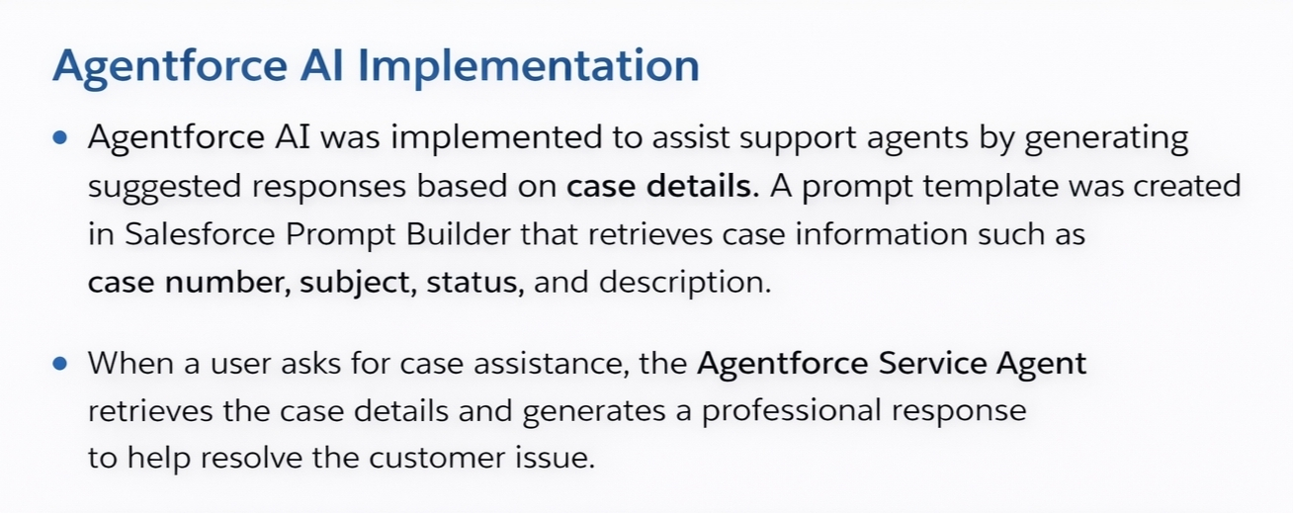

9. Data Architecture and Object Model

The system uses a combination of standard and custom objects to organize customer and support data.Account stores information about companies or organizations. Contact stores details about individual customers. Cases
represent support requests raised by customers.
Custom objects include Support Category, which defines issue types; SLA Policy, which determines resolution time targets; and AI Feedback, which captures agent feedback regarding system-generated suggestions.
These objects are linked through relationships to maintain structured and consistent data across the system.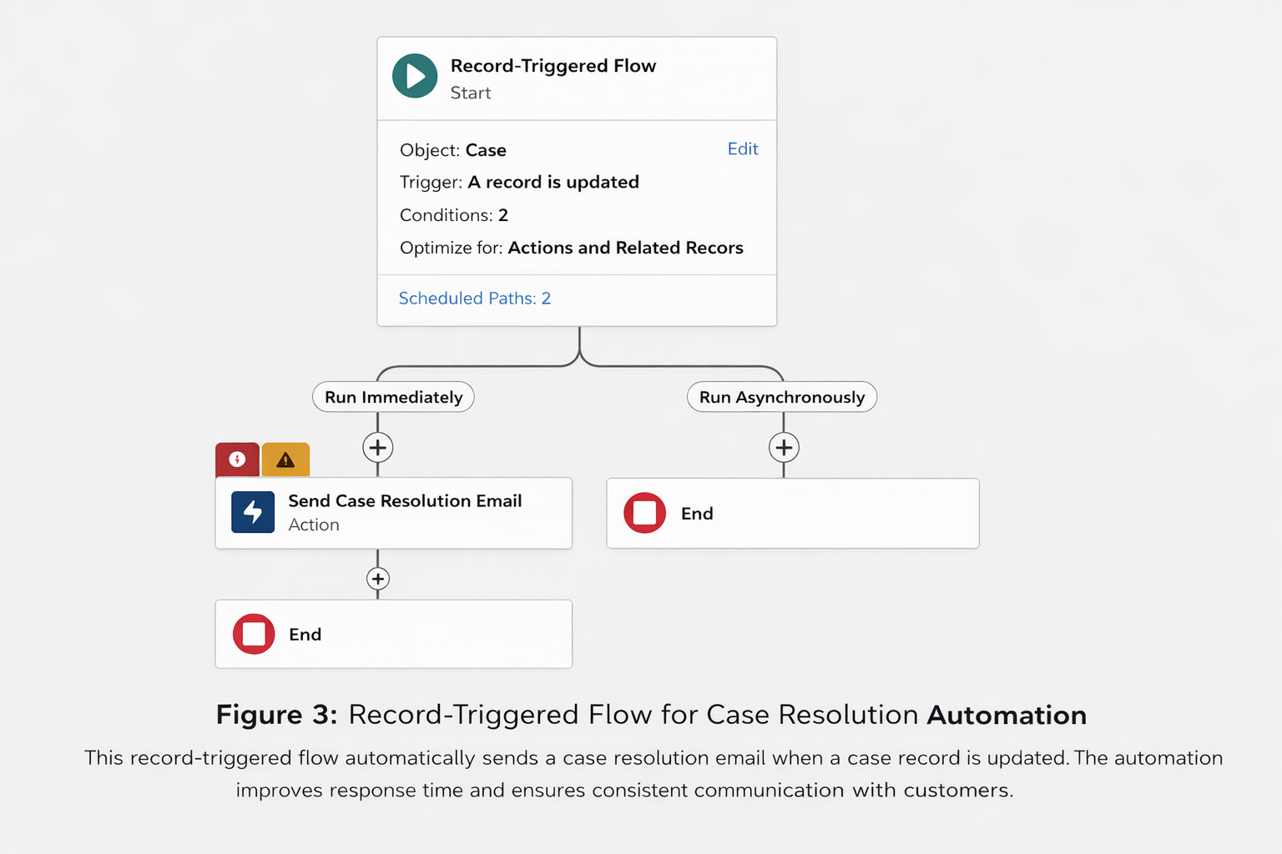

10. Automation Logic
Automation plays a critical role in improving efficiency in the support process.Record-tiggered flows are used to automatically classify cases based on keywords or selected categories. Priority assignment logic determines whether a case should be marked as High, Medium, or Low priority.
Another flow calculates SLA due dates based on predefined policies. This ensures that each case has a clear deadline for resolution.Automation reduces manual effort and helps agents focus more on solving customer issues.

11. Security Model
Security is implemented using role-based access control in Salesforce.Profiles define the basic permissions assigned to users such as support agents or managers. Permission sets provide additional access when required.
This approach ensures that users can only access the data and functionality relevant to their role. It also protects sensitive
information and maintains system integrity.

12. Reporting and Monitoring
Reports and dashboards are used to monitor the performance of the support system.Managers can track metrics such as total cases created, cases resolved, cases pending, and SLA breaches. These insights help identify bottlenecks and improve operational efficiency.
Monitoring also includes evaluating automation performance and verifying that flows are functioning correctly.

13. AI Feedback Loop
The AI feedback loop allows support agents to provide feedback on suggested actions generated by the system.
Agents can indicate whether the suggestion was helpful or not. This feedback helps evaluate system effectiveness and identify areas for improvement.Over time, feedback data can be used to refine automation rules and improve decision-making.

14. Testing
System testing ensures that all components of the solution work as expected.
Testing activities include verifying case creation, checking automation flows, validating SLA calculations, and confirming security access for different user roles.
Successful testing confirms that the system meets the defined requirements.

15. Maintenance and Troubleshooting
Regular maintenance ensures that the system continues to operate smoothly .Administrators review flows, custom objects, and field configurations to ensure alignment with business needs. Monitoring activities include reviewing reports, checking SLA compliance, and evaluating automation performance.
Troubleshooting involves analyzing flow errors, reviewing debug logs, and identifying configuration issues. Corrective actions may include updating flow logic, modifying field permissions, or adjusting decision conditions.

16. Learning Outcomes
This project provides practical experience in Salesforce administration and automation.
Key learning outcomes include understanding Salesforce data models, designing automation using flows, implementing security controls, and building reports for monitoring.
The project also demonstrates how automation can significantly improve the efficiency of business processes.
17. Output of the project
Resource inserted:
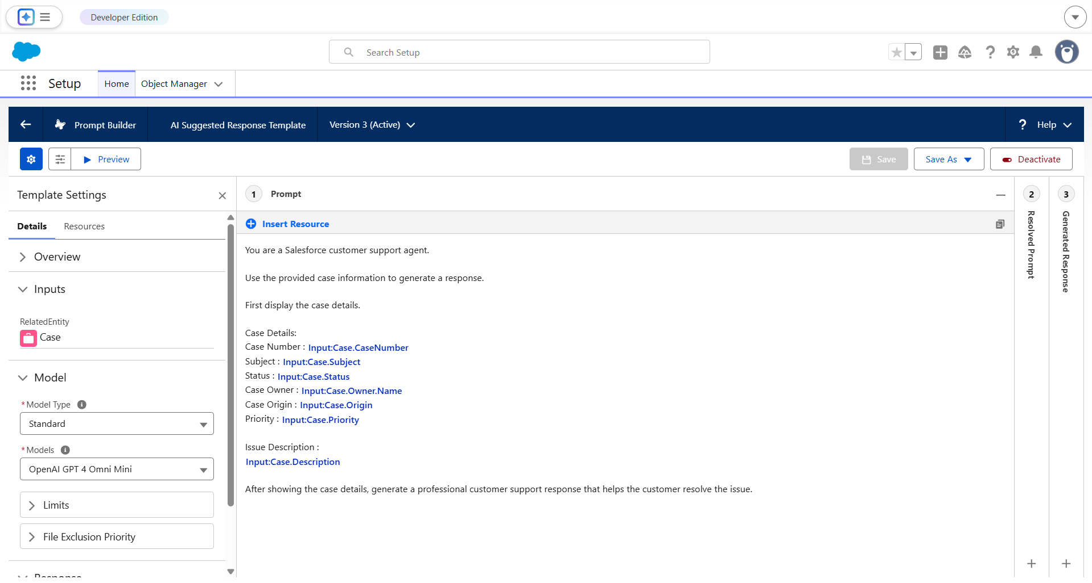
Output:
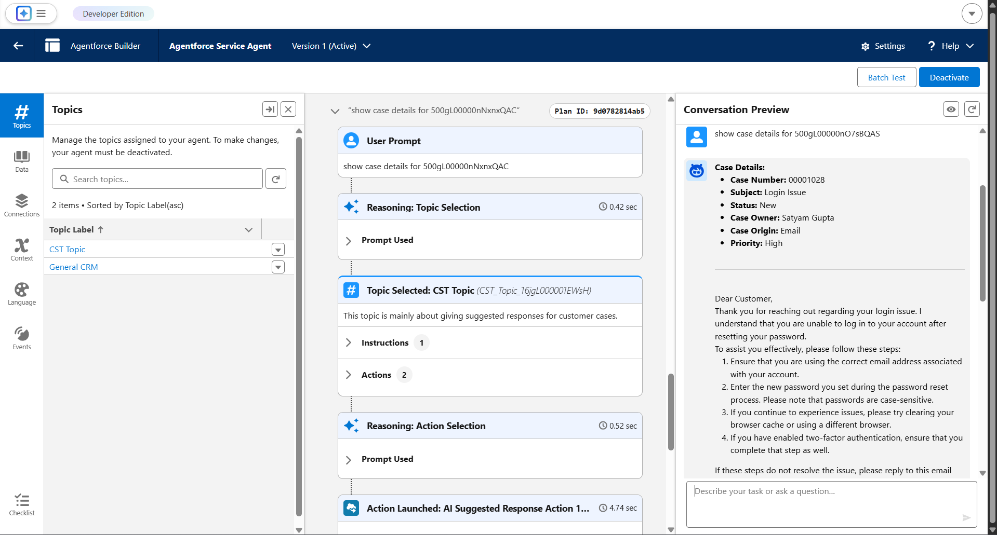

18. Conclusion
The Salesforce AI-Powered Customer Support Ticketing System demonstrates how intelligent automation and structured data management can enhance customer support operations.
By leveraging Salesforce standard and custom objects, automation flows, and security controls, the system improves efficiency and ensures timely issue resolution.
Overall, this project provides a scalable and practical solution for managing customer support operations using Salesforce.
19. Team Members and responsibilities
Satyam Gupta  Responsibilities :  - Stakeholder mapping as part of the requirement analysis process.  - Design of data architecture for backend development and system configuration in Salesforce.  - Defining and documenting the steps required to implement the system.  - UI/UX configuration and customization of system reports.  - User configuration and management within the system. | Shivam Gupta  Responsibilities:  - Preparation of the execution roadmap for system implementation.  - Configuration of fields and relationships development and configuration in Salesforce.  - Implementation of validation rules to ensure data accuracy and consistency.  - Configuration of Agentforce AI for intelligent automation.  - Setup and customization of the Lightning App.  - Configuration of profiles for system users.
Utkarsh Mishra  Responsibilities:  - Deployment, Documentation & Maintenance  - Helped in structuring and organizing the project documentation, including the problem statement, solution approach, system architecture, and implementation details. | Ankita kaushik (Team lead)  Responsibilities:  - Functional mapping and requirement analysis for the customer support ticketing system.  - Creation and setup of a developer account on Salesforce.  - Configuration of application tabs for efficient navigation and access to system objects.  - Implementation of email alerts as part of backend development to automate system notifications.

